Wireshark Project

1. Which IP accessed [www.willselfdestruct.com](http://www.willselfdestruct.com)?

* Based on my analysis, the IP address that accessed [www.willselfdestruct.com](http://www.willselfdestruct.com) is 192.168.15.4

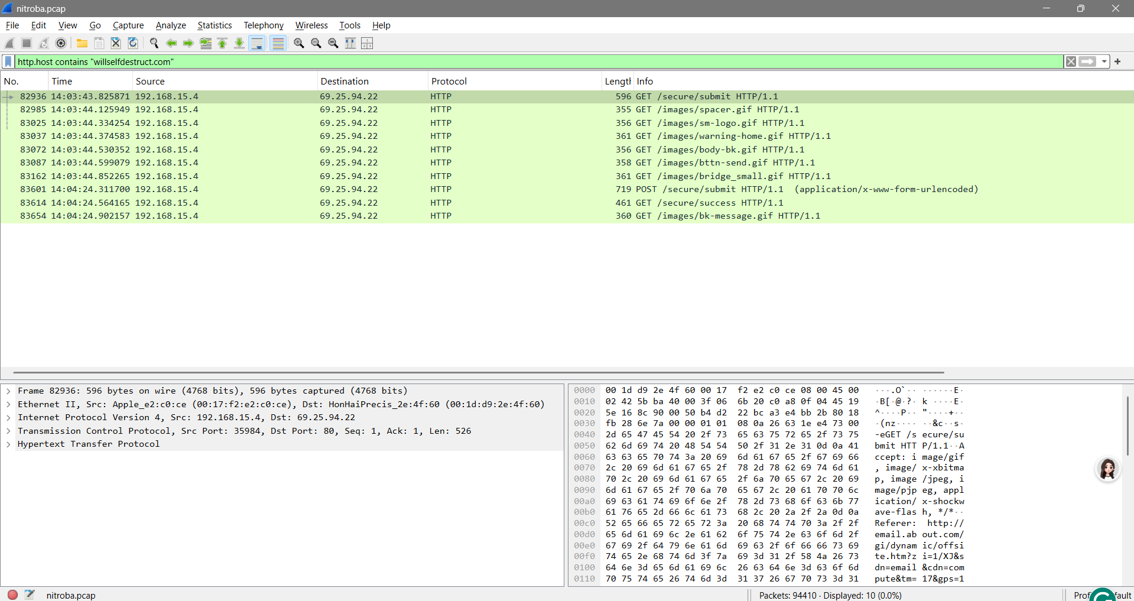

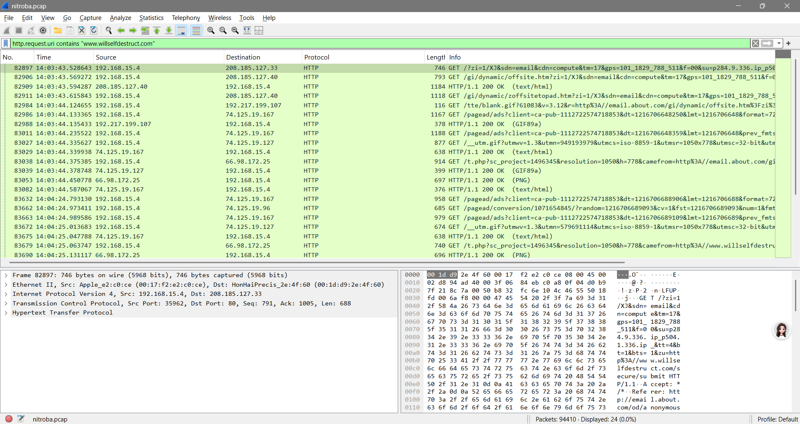

1. Does the IP post harassing comments to the website?

* Based on my analysis and observation, yes, the IP posted harassing comments to the website.

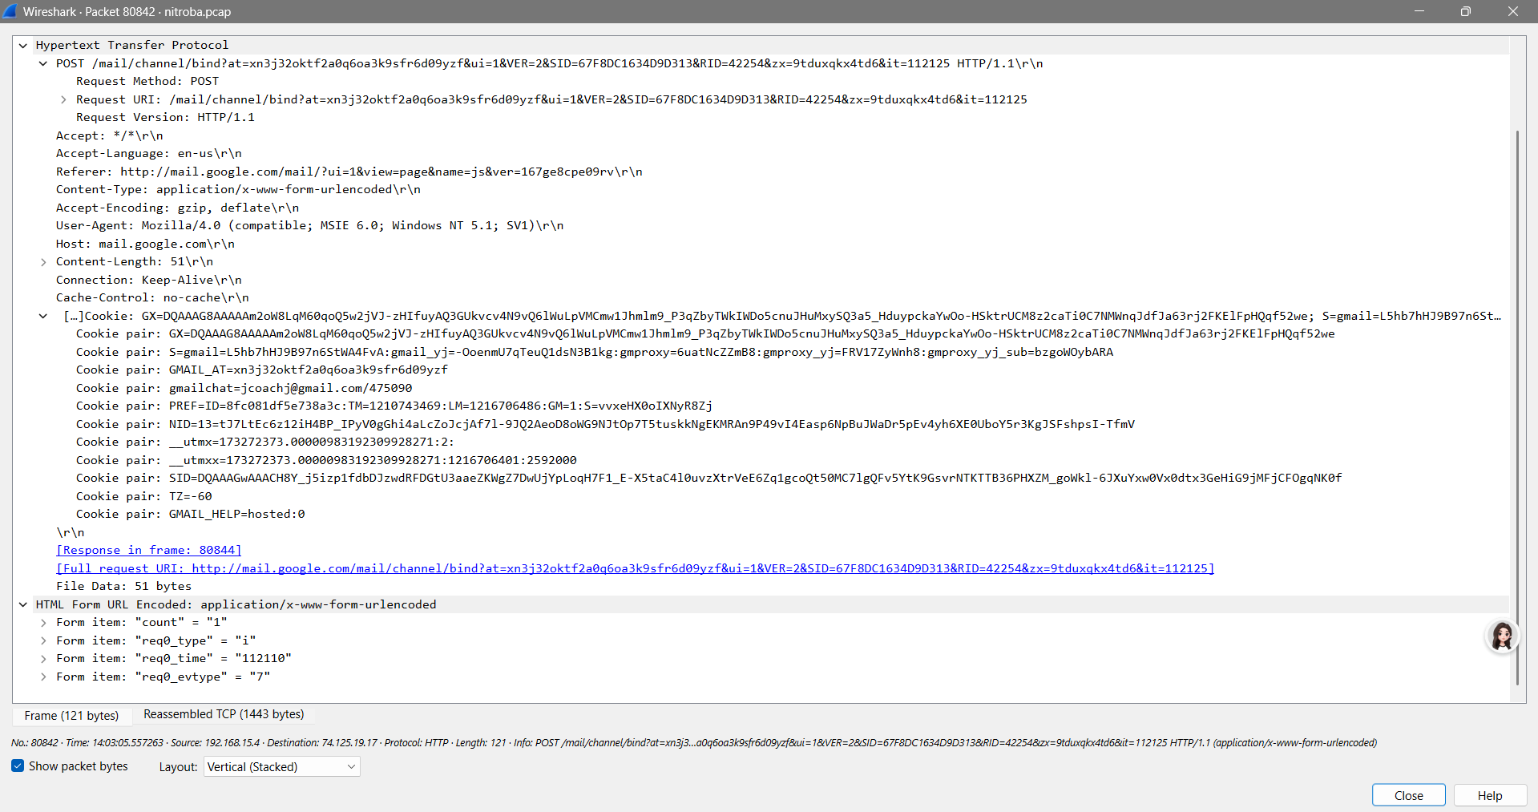

1. Does the HTTP post contain the harassment message?

* Based on my analysis and observation, yes, the HTTP post contains a harassing message.

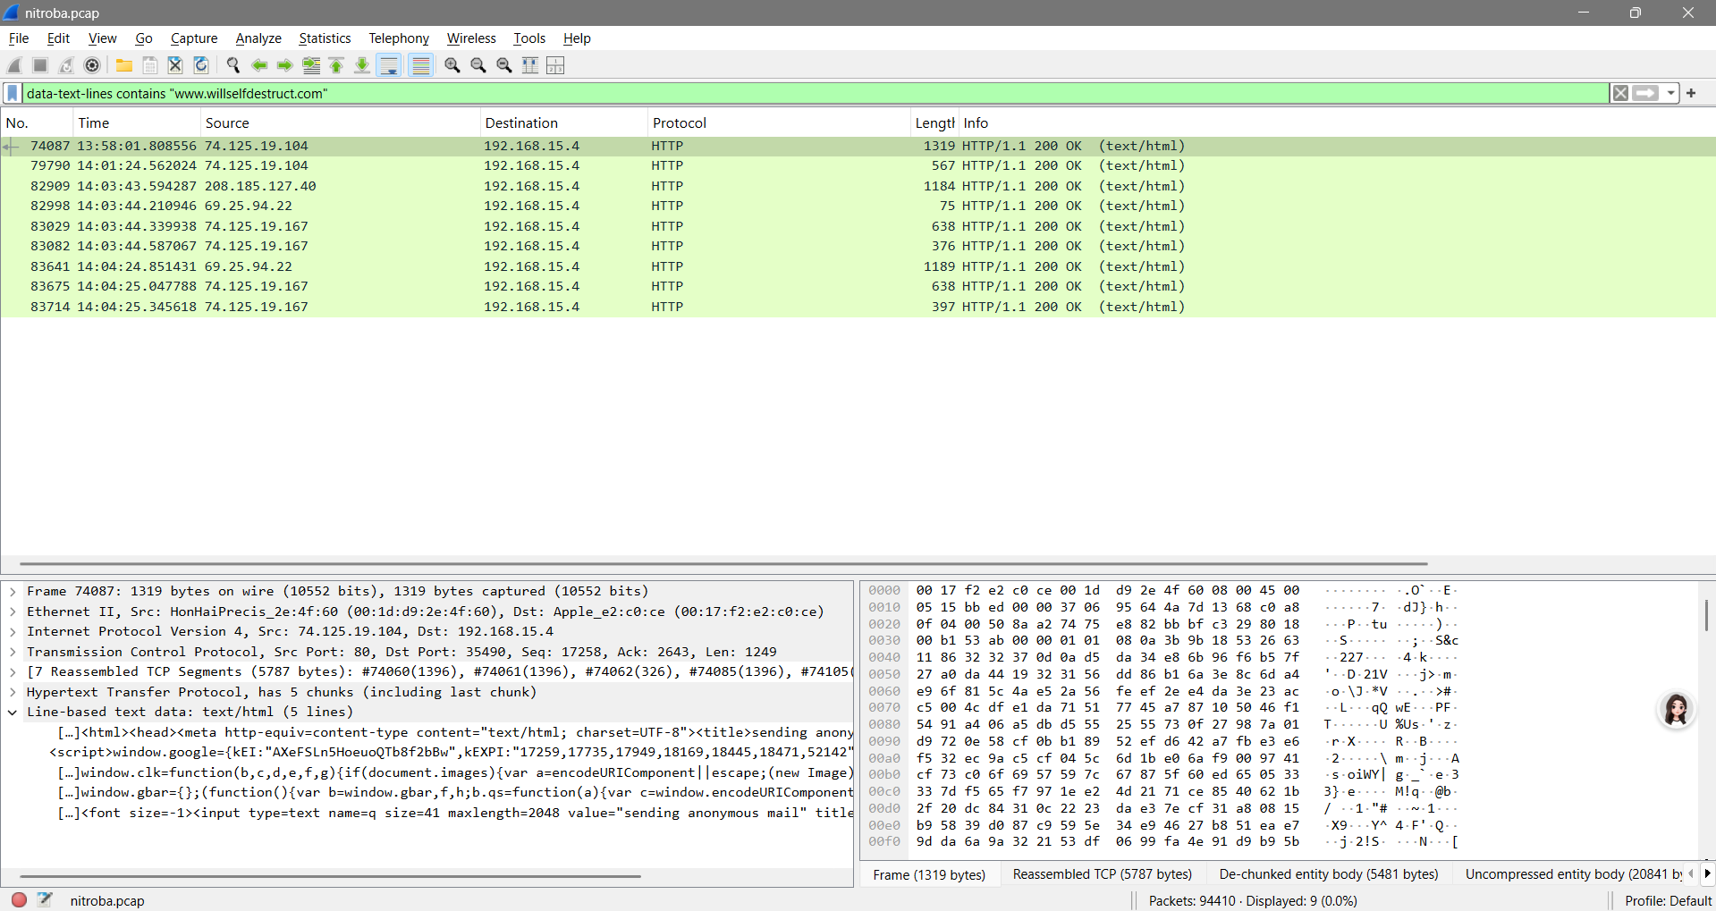

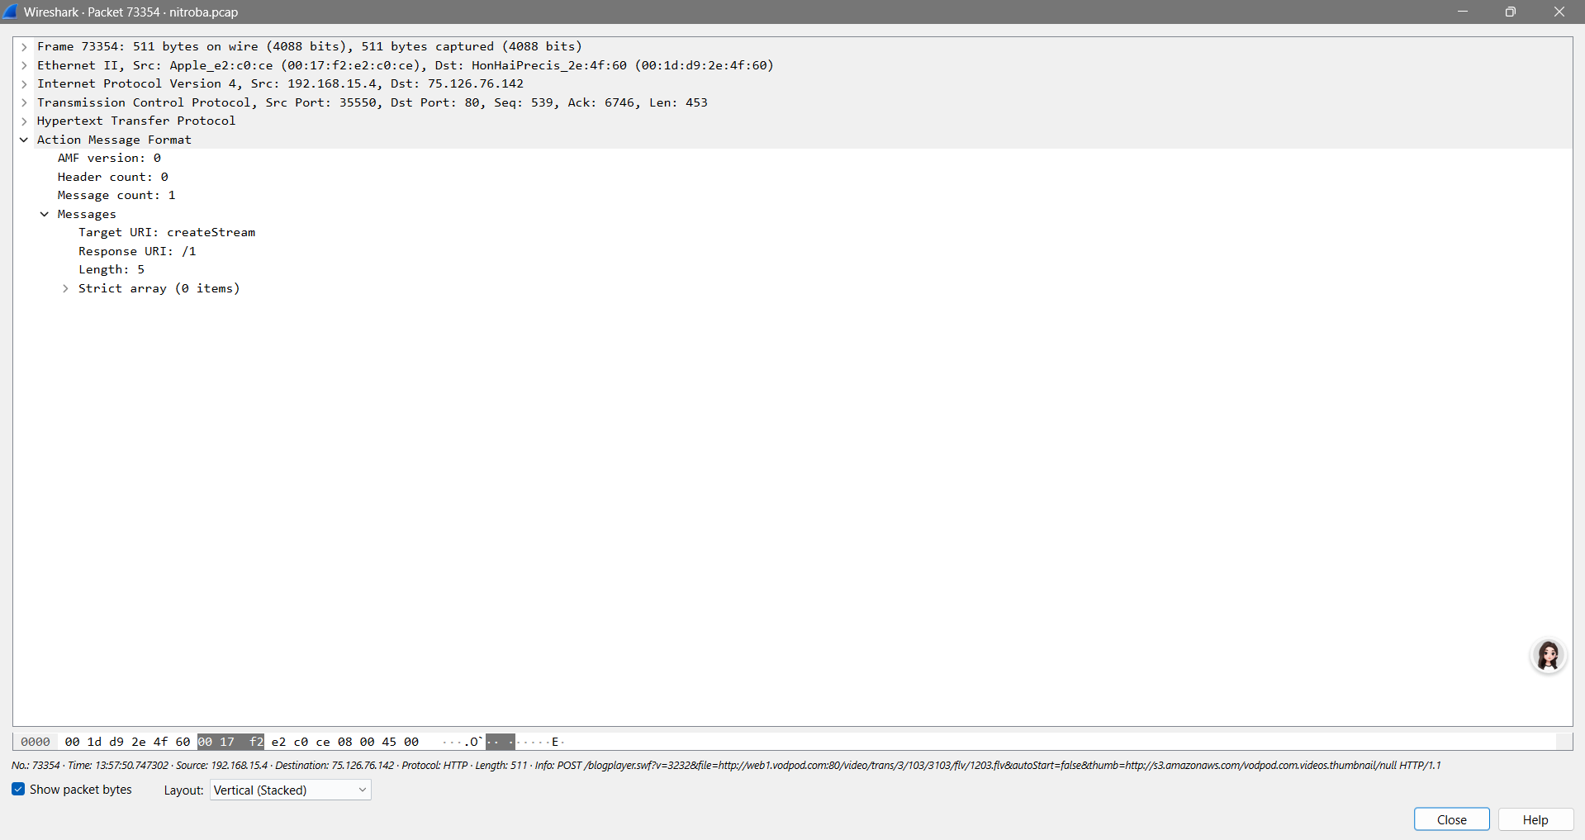

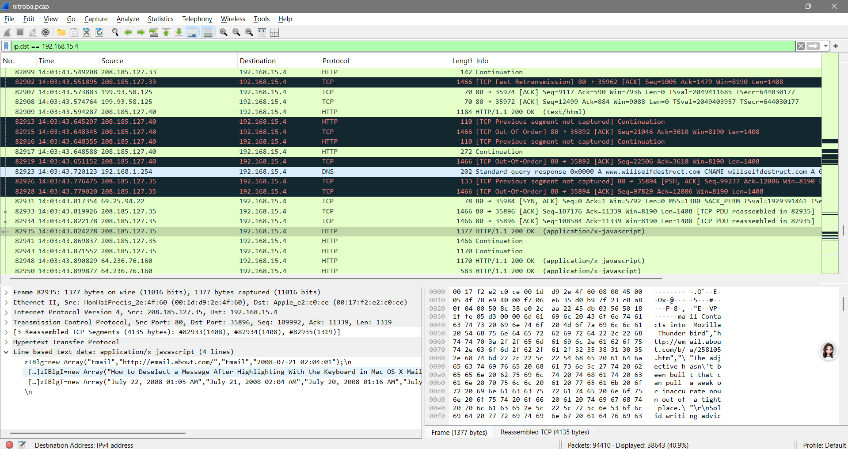

1. Is the IP associated with any suspects?

* Based on my analysis and observation, I can say that the IP address 192.168.15.4 is related to the students.

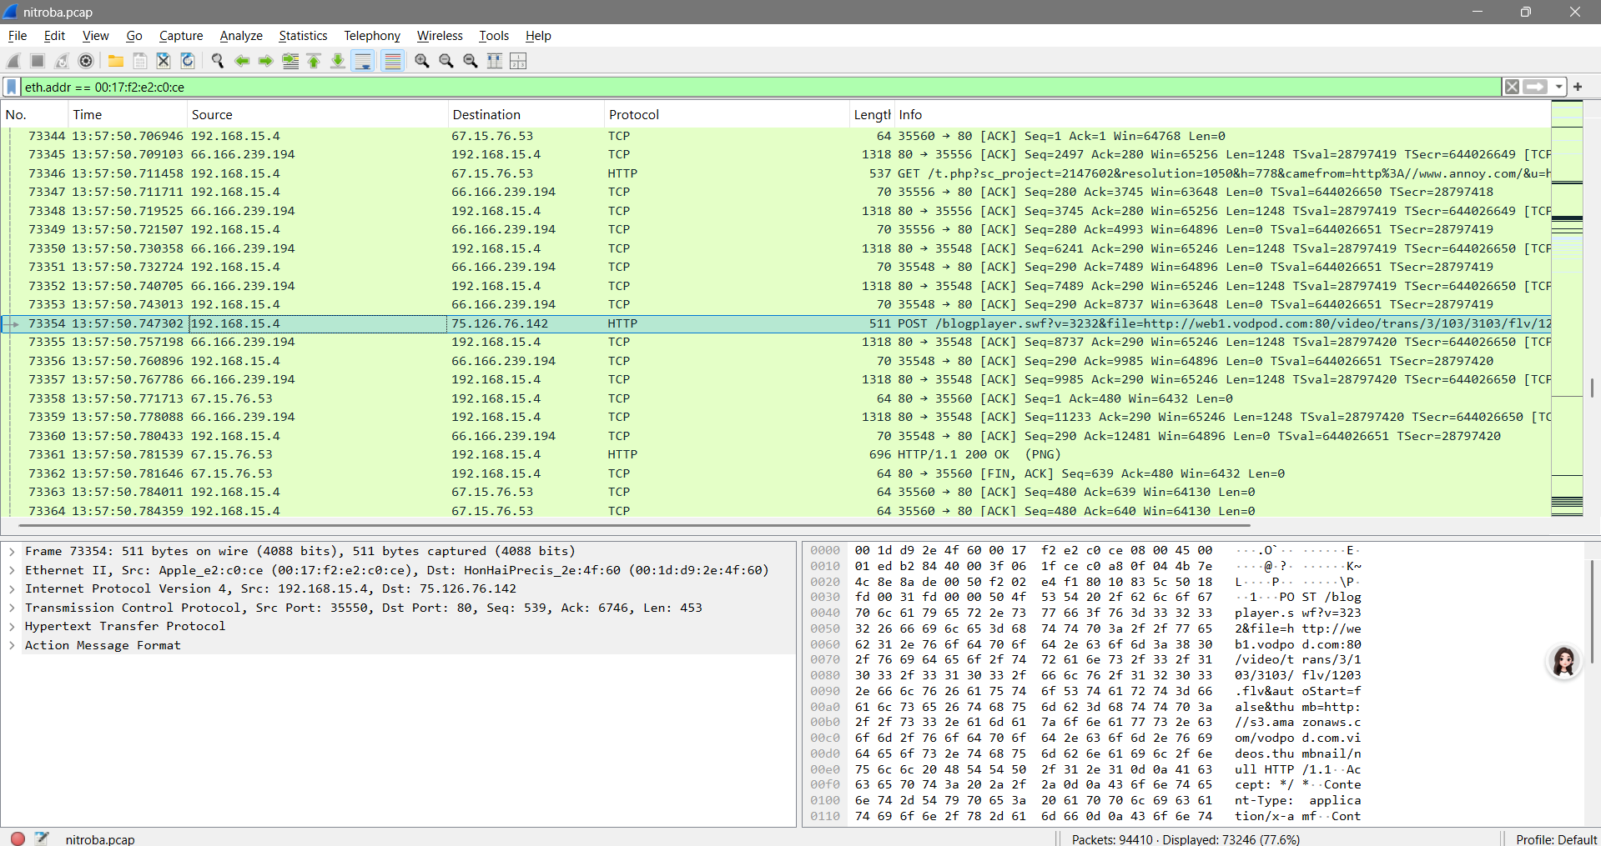

1. Is the suspect in the faculty’s class?

* Based on my observation and analysis, yes the suspect is in the class and it is Tuck Geoge.

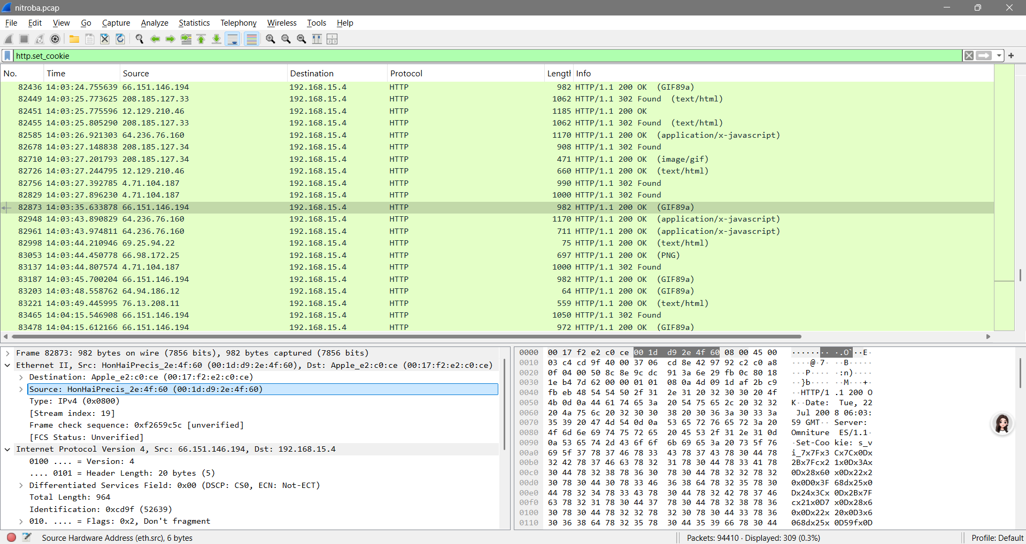

1. When did the suspect use [www.willselfdestruct.com](http://www.willselfdestruct.com)?

* Based on my observation, the suspect used the website above on July 22, 2008

